**CTF Challenge: Decrypting Encrypted Message Using Basic Cryptography Techniques**



# **Introduction**

Encryption involves converting plaintext into ciphertext to protect data confidentiality. Decryption reverses this process, requiring knowledge of the encryption algorithm and, often, a specific key to restore plaintext from ciphertext. Understanding these techniques whether symmetric (using the same key for encryption and decryption) or asymmetric (using public and private keys) is crucial for securely transmitting and interpreting sensitive information.



# Tools Required

**Text Editor**: To view and manipulate the encrypted file.

# Scenario

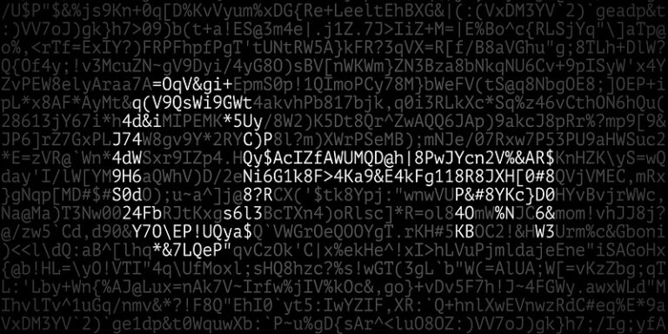

You discovered a file named Q3J5cHRvLnR4dA==.encr containing an encrypted message. The key for decryption is embedded within the encrypted file itself. Your task is to decrypt this file using the embedded key to reveal the original plaintext message.

# 

# 

# 

# 

# Process to Follow while performing CTF

**Step 1: Online Tool:** <https://www.devglan.com/online-tools/file-encryption-decryption>

**Step 2: File link:**

<https://www.mediafire.com/file/mccq9lwft9k895n/$the@key&is#6.encr/file>

**Step 3:** Download the file and after downloading, you can see the secret key in the downloaded file name. Try to identify the key.

**Step 4:** After finding the key, decrypt the downloaded file using its secret key and another file will be downloaded. Open the new downloaded file

**Step 5:** Capture the Flag

# Question

Flag 1 What was the key to decrypt the encrypted file?

Answer: 6

Flag Captured

Flag 2 What was the first word of the decrypted plaintext message?

Answer: Congratulations

Flag Captured

# 

# 

# HINT

